The pseudocode I used for the program is as follows:

1. Introduce the program;
2. Appropriately declare and input the two numbers;
   1. Convert them to double numbers;
   2. Use them as arguments to call the method in the class define in 2 below
3. Check for the greater of the two and assign the value to a variable in a new class;
   1. If they are equal, say so;
   2. Say goodbye;
4. Print the result.
5. Say goodbye;

The main program, GreaterOf2Numbers, consists of the input statements using JOptionsPane; conversion of the input strings to the required double numbers; and a call to the method, gr81of the class GreaterXY. Both classes were stored with a .java extension and compiled together using the javac command.

The class GreaterOf2Numbers has contains 2 methods for introducing the program (welcome()) and a goodbye method (goodbye()).

Manipulation within GreaterXY to get the larger number involved the use of the “if” statement. It was easier to check for “<”, “>” and “=” separately using the if…else if…else construct. I included a call to the goodbye method there prior to ending the program.

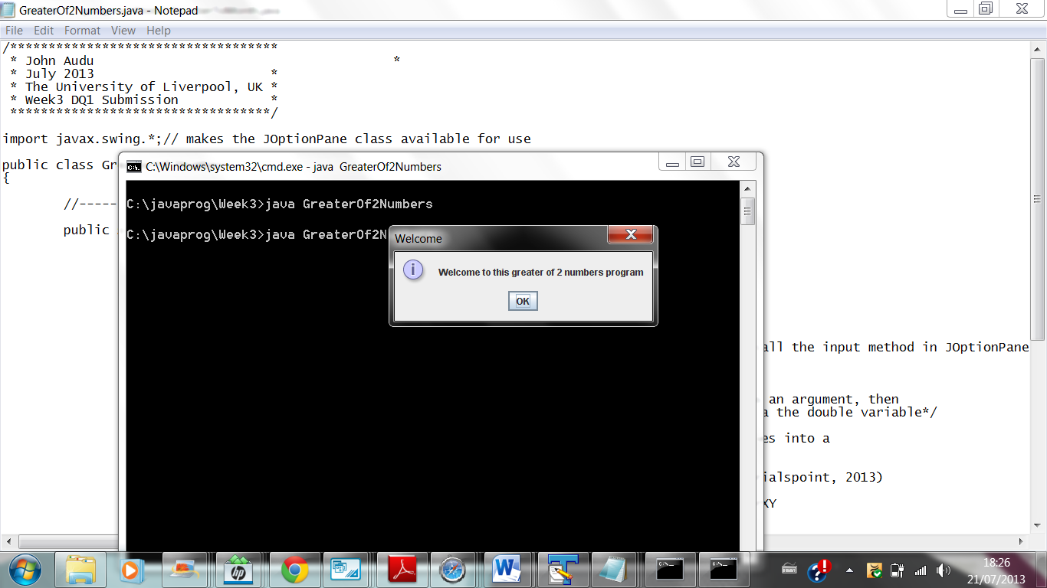

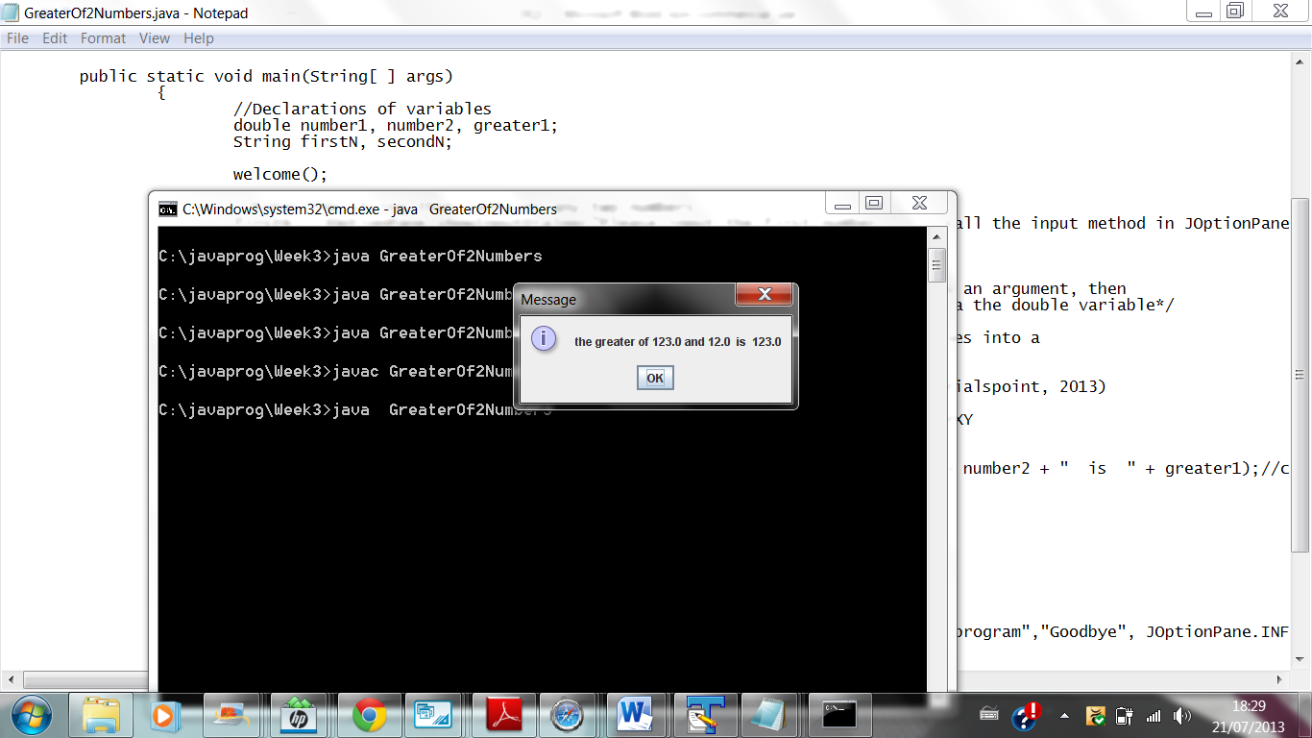

# Bibliography

Deitel, P. & Deitel, H., 2012. *Java How To Program.* 9th ed. Boston: Pearson EDucation Inc..

Laureate Education B.V., 2000-2007. *Java Programming.* [Online]   
Available at: https://elearning.uol.ohecampus.com/bbcswebdav/xid-584666_4  
[Accessed 7 July 2013].